**Lab 8: Using Jasmin to run x86 Assembly Code**

**Course Name**: Malware Analysis and Reverse Engineering (IAM302)

**Student Name**: Nguyễn Trần Vinh – SE160258

**Instructor Name**: Mai Hoàng Đỉnh

**Lab Due Date**: 15/2/2023

**Purpose**

To practice writing and running basic x86 assembly code, using the Jasmin interpreter

**What You Need for This Project**

* Any computer, running any OS

**Install Java**

**Download Jasmin**

**Understanding the Jasmin Window**

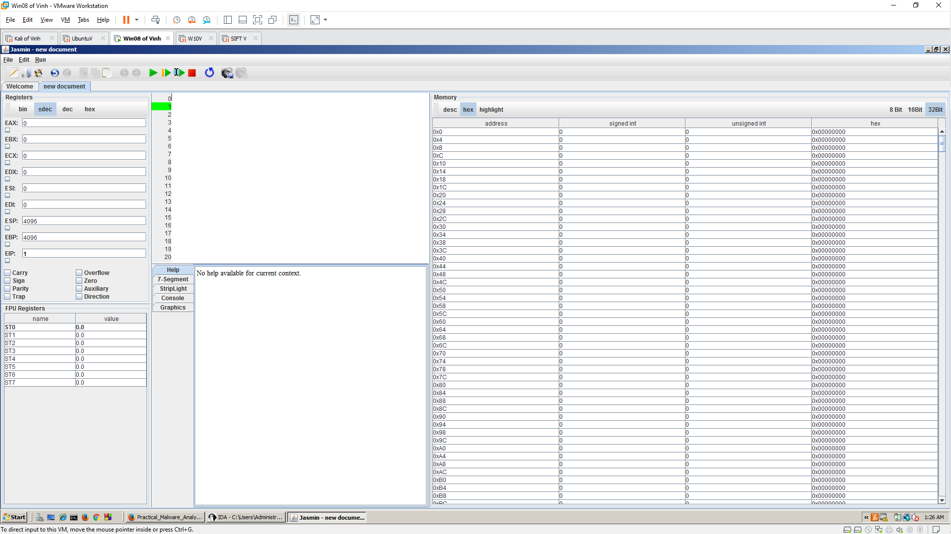

**Registers**

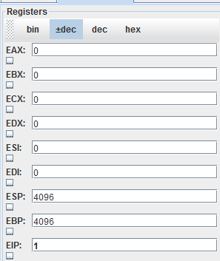

**Flags**

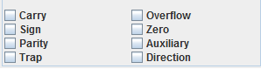

**Code**

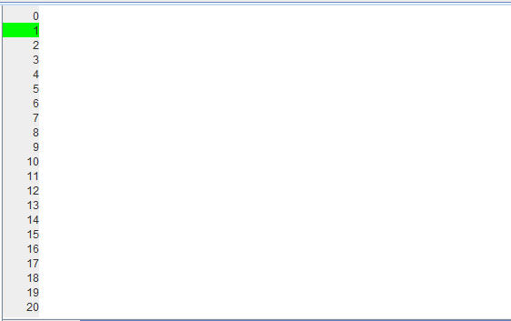

**Help**

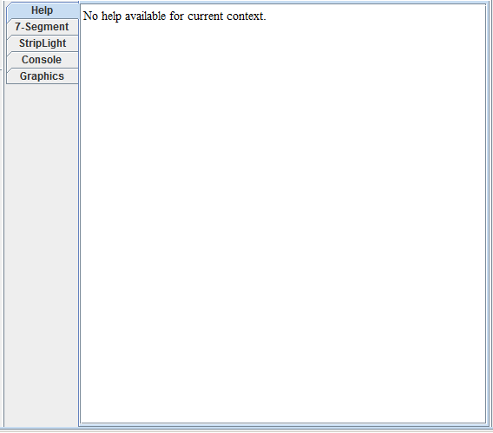

**Memory**

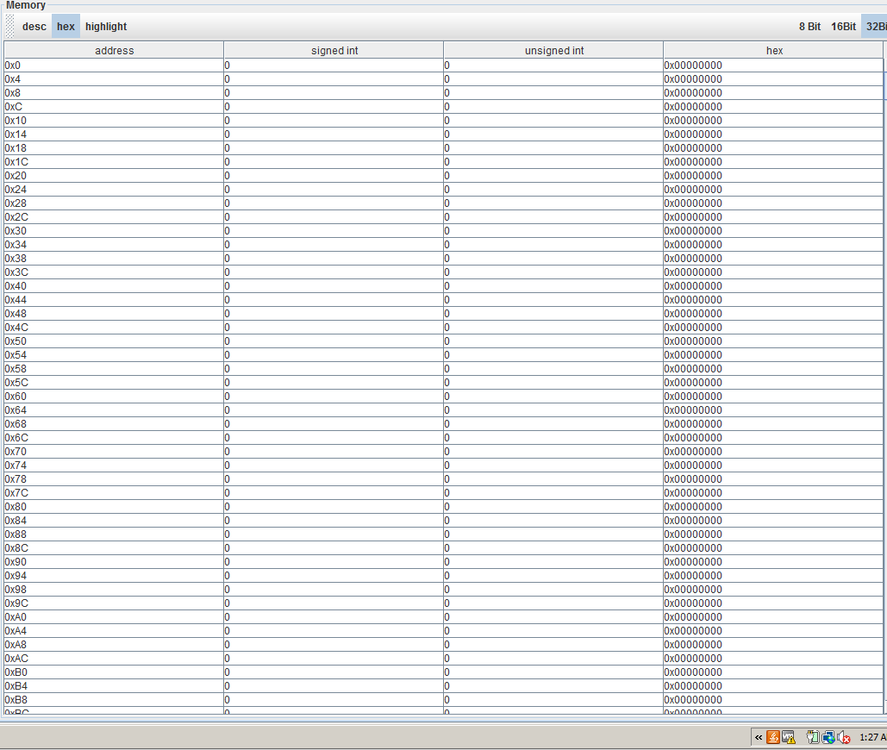

**Using mov Instructions**

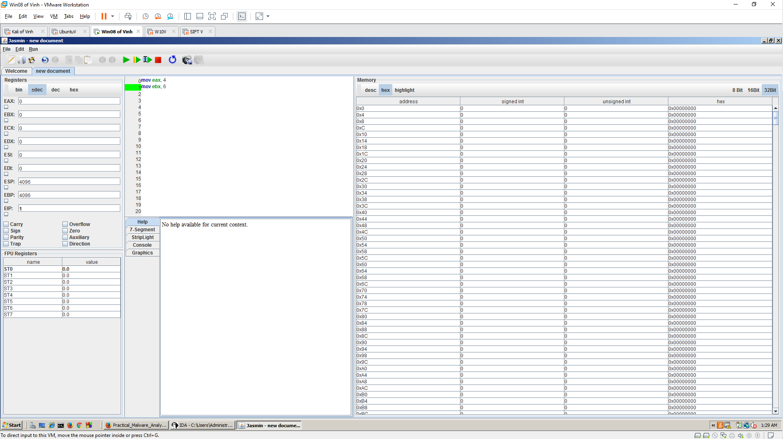

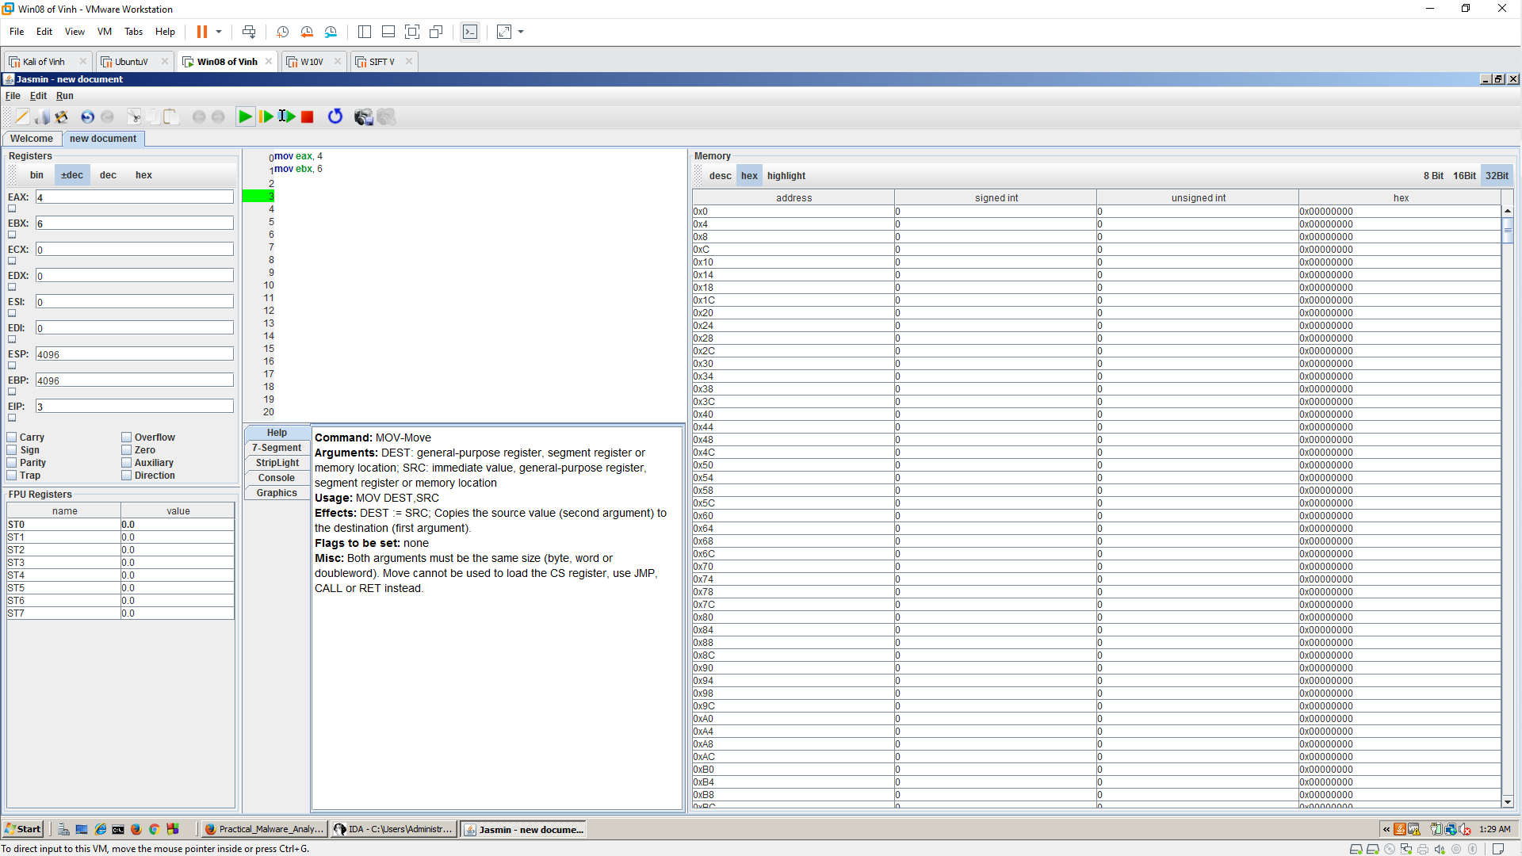

**Storing Results in Memory**

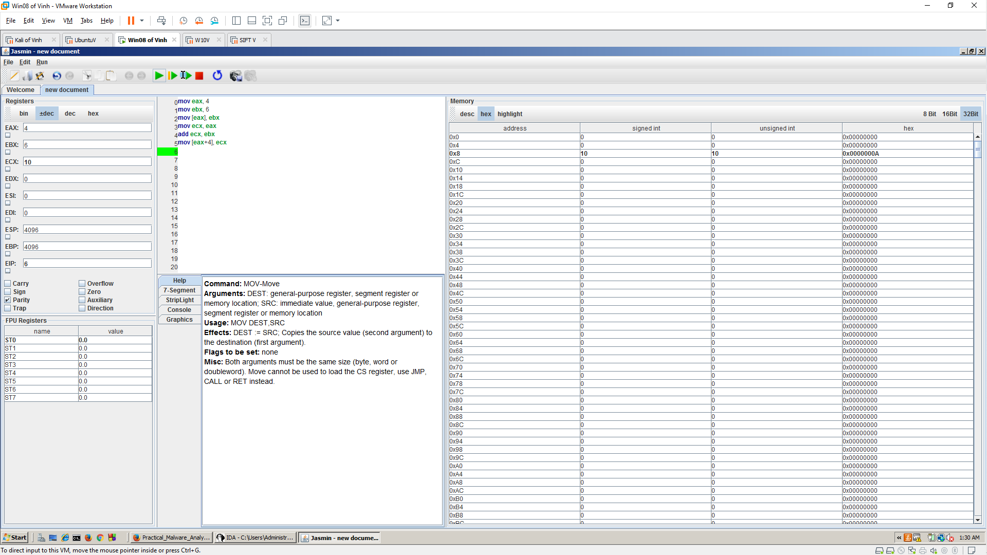

**Using the Stack**

**Push**

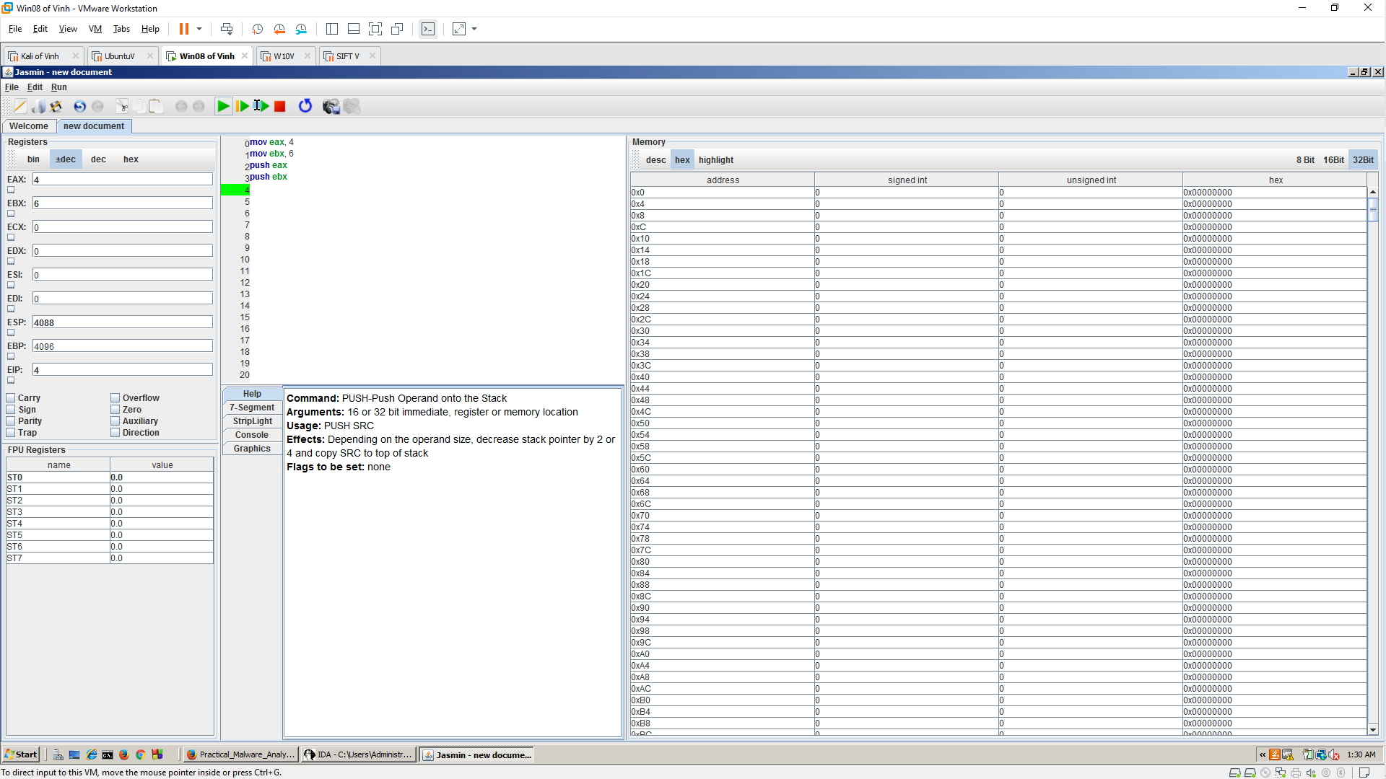

**Pop**

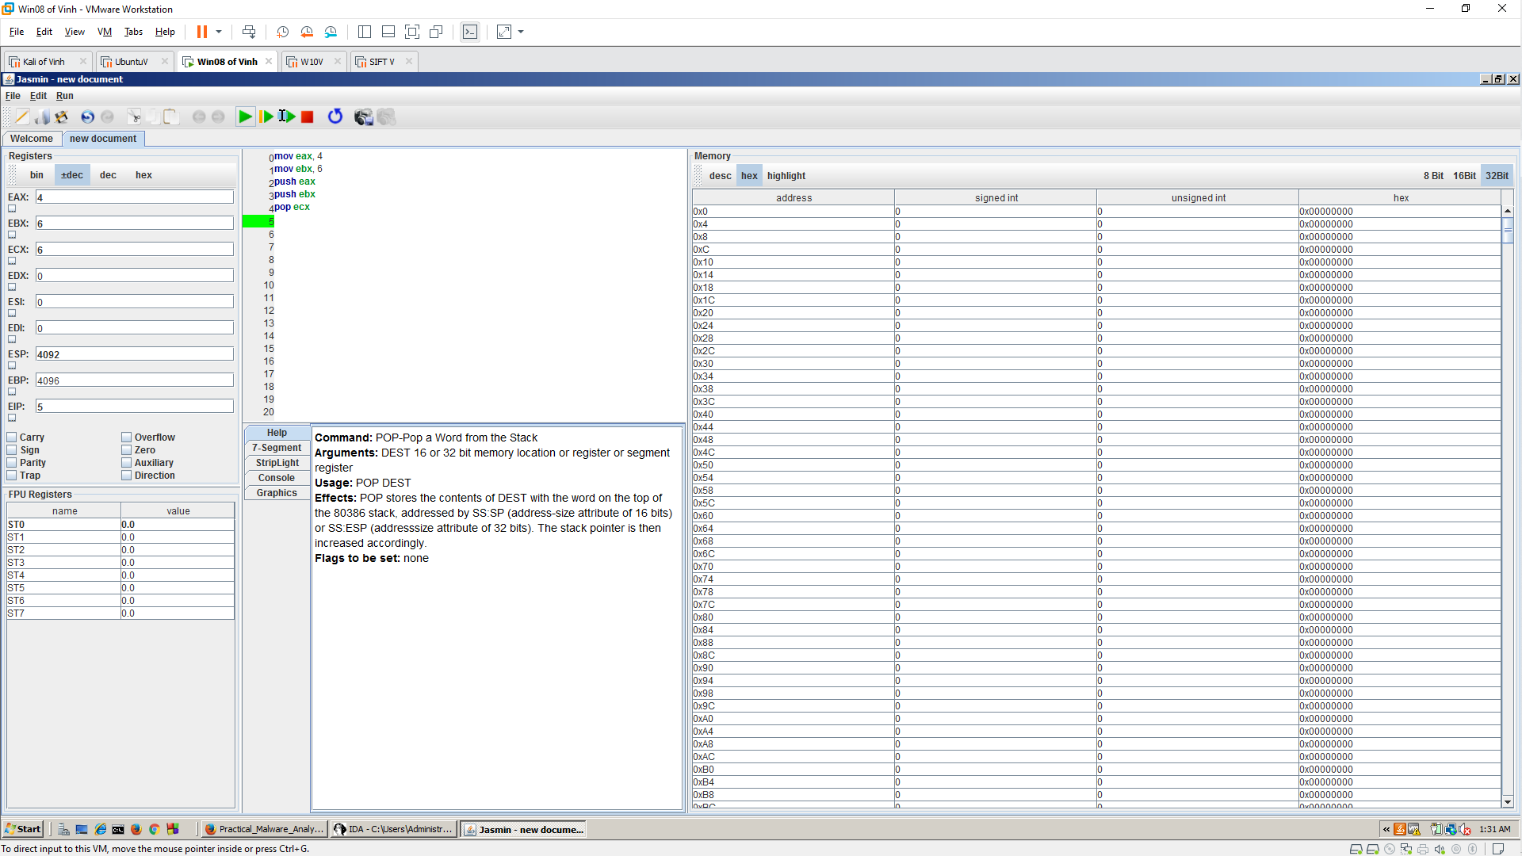

**Reversing a Sequence**

